# Reading Data

## Agenda

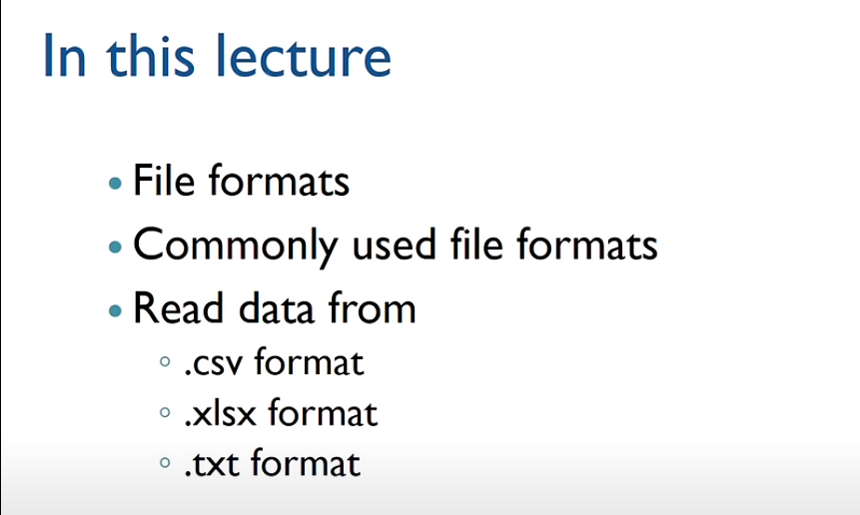

## File Format

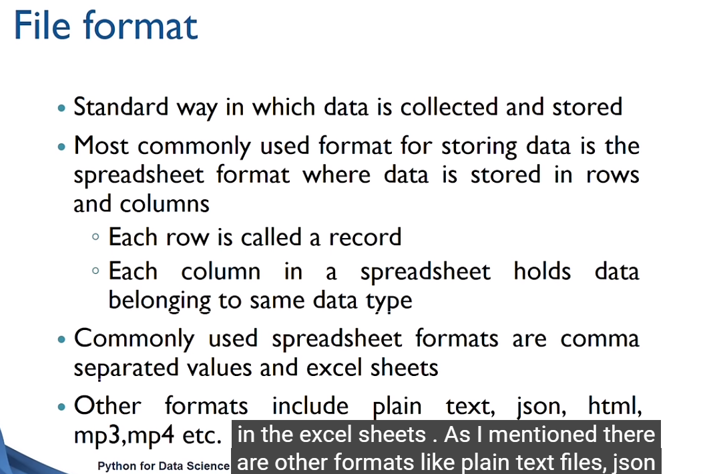

### Comma separated values (csv) format

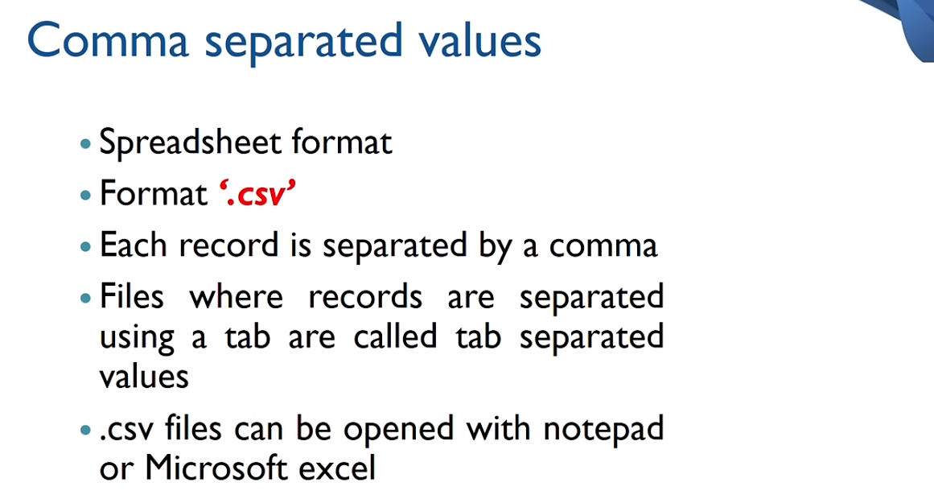

Comma separated values in a notepad. It is hard to read which value belongs to which column(variable).

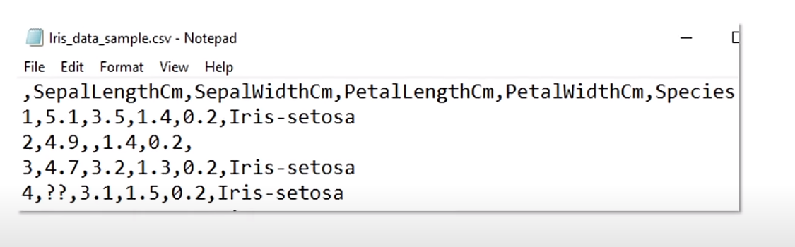

Comma separated values in an excel sheet. It is easy to read.

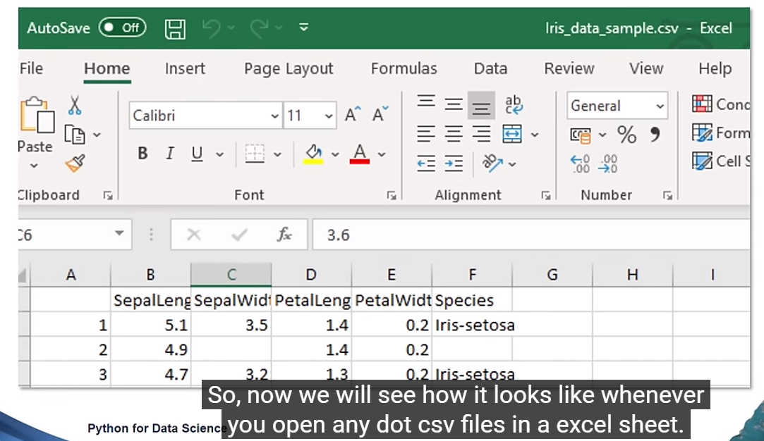

### Excel (xlsx) format

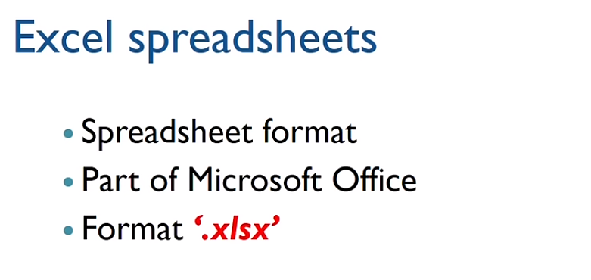

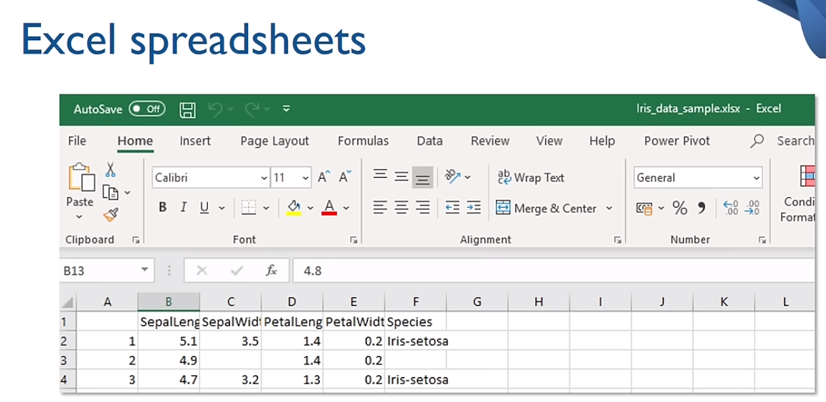

### Text (txt) format

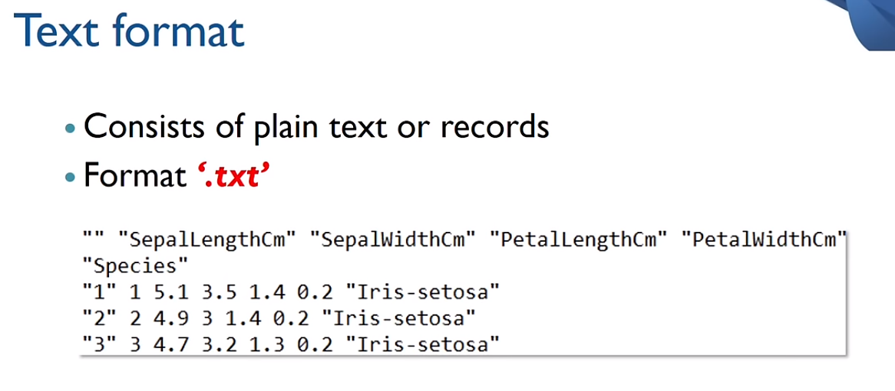

It can contain the data purely in the text format.

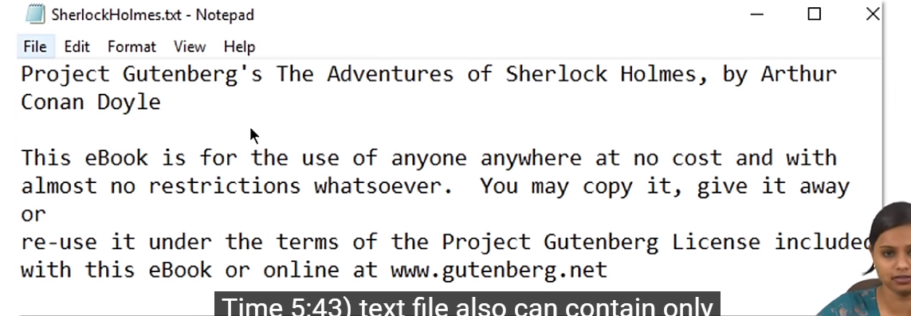

## Importing Data

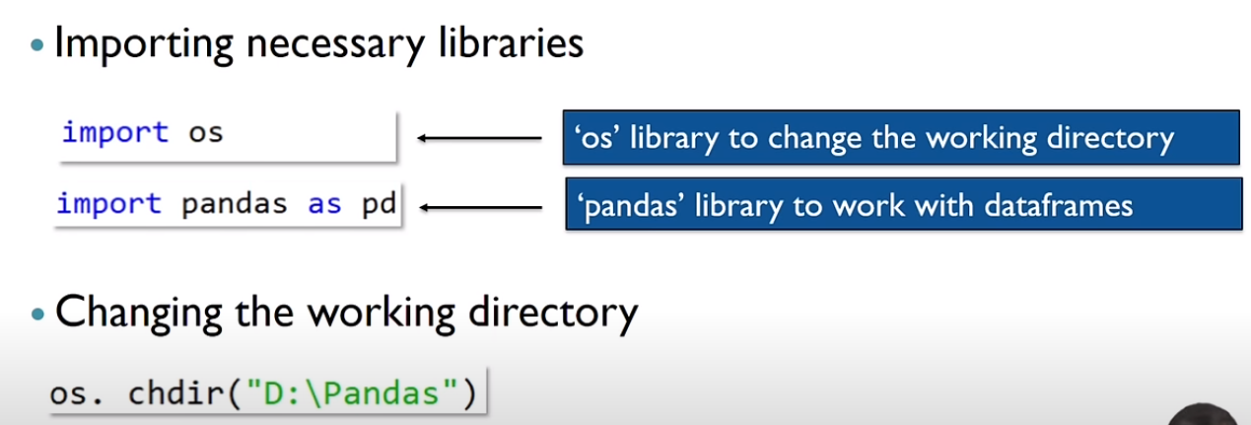

Use Panda’s dataframes to import the data from the file.

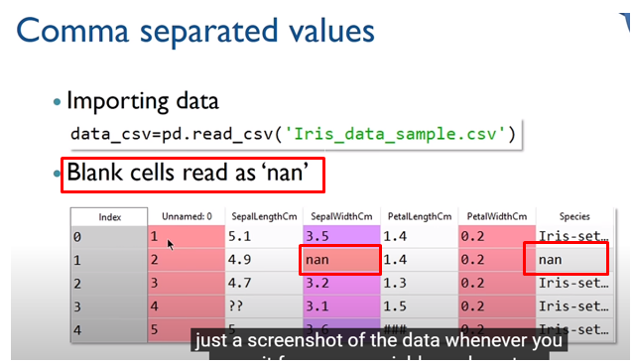

In Pycharm, start in debug mode

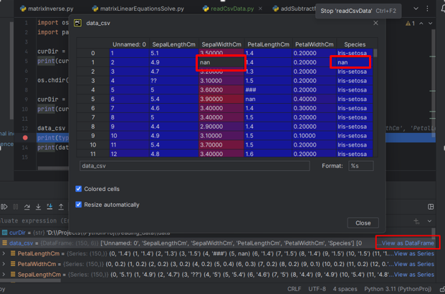

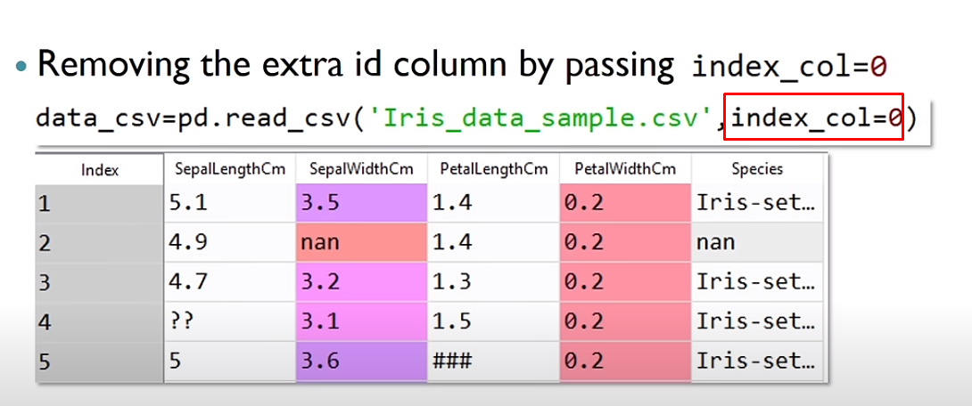

0th column of csv file will be considered as an index col, so Pandas won't add its own index column

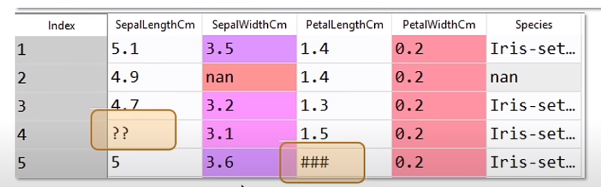

Let’s say, you got the data in such a way that ?? and ### are represented as missing values. Pandas will replace only blanks as NaN. You can replace all ?? and ### with NAN.

